**A PROJECT ON PERFORMING VARIOUS OPERATIONS ON WEB PAGE USING DOCKER**

-***Harsh Gupta***

My project is based on docker containers. To run various things like apache server on container.As

A normal os takes more time to setup in a system.But docker is superfast as it can launch any os in just 1 second which has its own ram . Now you thinking that how it is possible,but actually there is reason behind this great technology. As a new OS launched,it creates their own kernel but in docker it uses the existing kernel. As I created a project on web using httpd inside centos7 image. It has various benefits as if your server is heavier then you can switch to different OS by just launching docker. Mainly ,It is used for bigger application like with a great technology Kubernetes. But now I launch a web container inside docker on redhat platform. I pull various images by using command:

e.g: ‘Docker pull’ centos on cli

Basically I create an image then push it . But In my project I have create my network using bridge driver as this connects my base system with my docker. I Also run it on windows . The steps for the project are as follows:

Step 1:

I pull the image centos

cmd:

* Docker pull centos

Step2: Then, I create a container

Docker run -it --name web centos:7

Docker ps -a

Step3: I install net-tools inside this os and also httpd

Cmd: yum install net-tools

Step 4: In this I commit this running os in the form image.

Cmd: docker commit web webserver

Step 5: Now I created a network using bridge driver

Cmd: docker network create –driver bridge mynetwork

Step 6: Then I created a storage for that file of docker:

Cmd:

Docker volume ls

Docker volume create web_storage

Step 7: Now I set environment for httpd inside webserver container

For that I have given cmd:

# Cd /var/ww/html

# Vi index.html

Then I write code for index.html for task selection add and delete additional task using js

Step 7: then ,I launch an image using mynetork ,web_storage,webserver container

First I flush iptables for patting

Cmd:

# iptables -F

#iptables -nvL

# Docker run -dit --name myproject --network mynetwork -- volume web_storage -p 80:1233

Webserver:latest

Then I type my ip:1233 on windows :

Step:8 The output of the project is as follows:

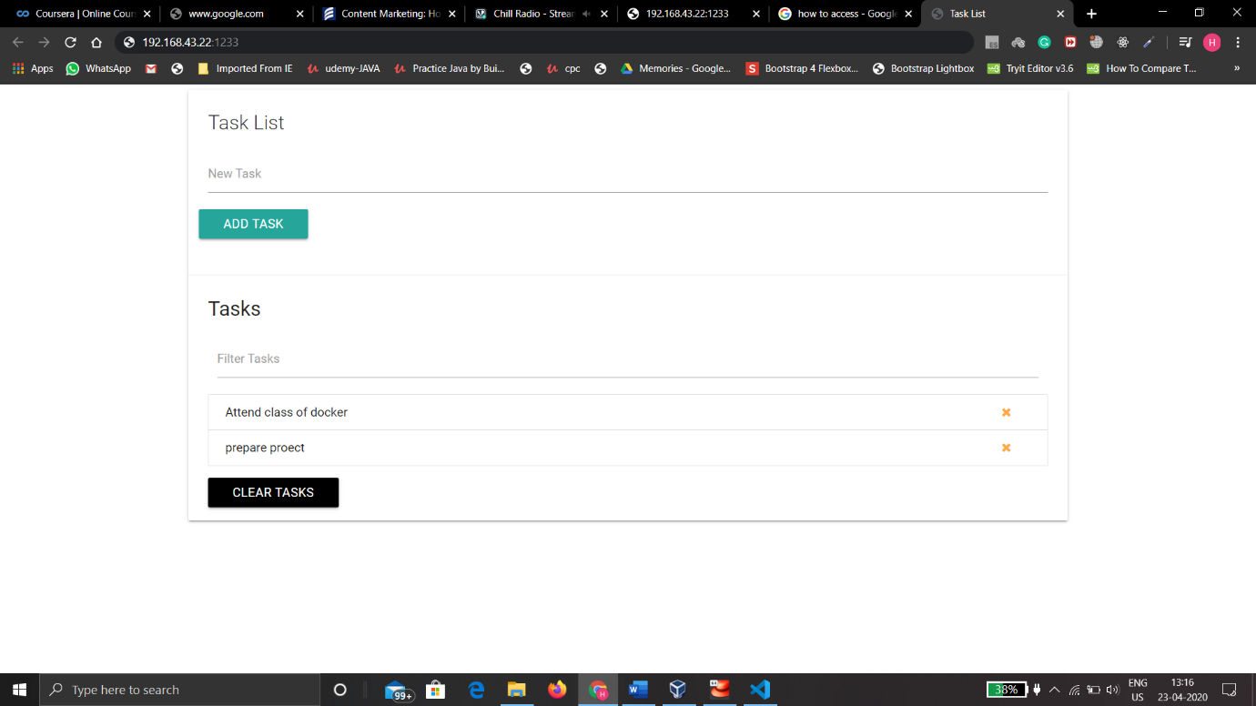

This is a small part of a big project as sometimes we forget what we have to done then we can add short notes usng this small task project on js.